***RAY.BAN 389***

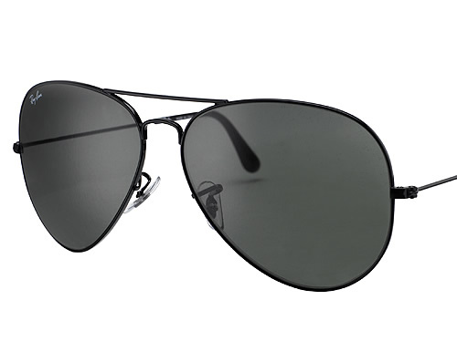

***DESCRIPTION:***

**RAYBAN’S GLASSES ARE ONE OF THE BRAND COMPANY OF ALL OVER THE WORLD.THEY ARE PROVIDE US VARIOUS COLOR OF GLASSES.THEY ARE HIGHLY SUITABLE OF EVERY FACE.THEIR COSTS IS ALSO VERY GOOD.**